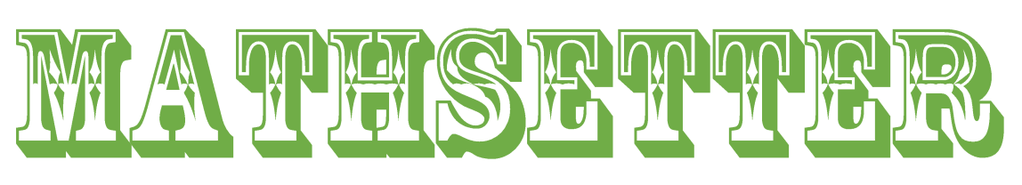



Emma Miller
How does it feel to have earned the title Mathsetter?
It feels it feels pretty awesome
Where plan to go to College:
University of Missouri
Do you plan to continue with math (directly or indirectly) in college?
Yes, I am planning on majoring in accounting, but I won’t be working with much Calculus
How many times have you laughed in class this year?
Absolutely none, math is no place for laughter.
What is your favorite song?
Hey There Delilah by the Plain White T’s... I could sing every word to this song since I was 2.
Person from the past that you would have most liked to meet?
Walt Disney
Does math come easy to you, or do you have to work at it?
Math is fun. Not easy, but definitely fun.
Activities Involved in at School:
Cheerleading, Link Crew, NHS, and Mathletes
Favorite Movie and/or Book:
Ratatouille, Another Cinderella Story: Dancing Ever After, or Guardians of the Galaxy
Favorite Fictional Character:
Spiderman or Daredevil
What is your favorite non-perishable food item?
Lightly salted almonds
What is your favorite article of clothing?
Sundresses
What is your favorite equation or formula?
Best piece of advice you have heard in school?
Get your homework done right when you get home, so that you have the rest of the night/ weekend to yourself.
What is the most recent search item you have attempted?
converse.com ... I may have a shopping addiction.
What is your favorite gift you have received or given?
Hugs are the best gift.
Favorite food or place to eat:
Chipotle or Panda Express
If you were an alien, what planet do you think you would come from?
Planet Her
How many times have you dropped your calculator in class?
Maybe like 5 times since freshmen year
What is your favorite kind of weather?
Sunny, 75 degrees, and a little bit of wind
What is your favorite hobby, why?
Making things like paper, books, ceramics, scrapbooks, or crocheting because it’s easy and something that you really don’t have to use your brain for
If you could choose, which decade would you like to have been born in?
The early 50s
What is your favorite word in the English (or any) language?
Fan-freaking-tastic

Which came first the chicken or the egg?
The Chicken?
What is your opinion on technology? Good or Bad?
Bad
If you could be a super hero, who would it be and why?
Spiderman because it’d be really fun to swing from building to building
What is your preferred method of tying your shoes?
Loop, swoop, through, and pull
Do you have a favorite number?
My favorite single digit number is 4.
AP Calculus - Is it as intimidating as it sounds?
No, but take BC. AB is way harder.
Any advice you would give to students who have to have Mr. C for a teacher?
Don’t drop your calculator and memorize the calculus song.
What is the most fun you have had in a Math class?
Geometry proofs
What is your favorite place to do your homework? Why?
Probably in a public library because it’s quiet and there are minimal distractions
What is your favorite joke?
I don’t think I have one
What is your favorite time of the day?
3:15pm
What is your LEAST favorite color?
Beige
Any story you would like to share about one of your classmates?
No
Is there anything else you would like to share?
I don’t think so :)

